# Panel Trends

## Panel 1 (GDPPerCapRealLCU_1)

Panel members include: Armenia; Australia; Belarus; Canada; Chile; Cote d’Ivoire; Czech Republic; Djibouti; Egypt, Arab Rep.; Georgia; Kazakhstan; Cambodia; Sri Lanka; Lesotho; Myanmar; Mozambique; Saudia Arabia; Sierra Leone; Suriname; Chad; Uganda; Zimbabwe

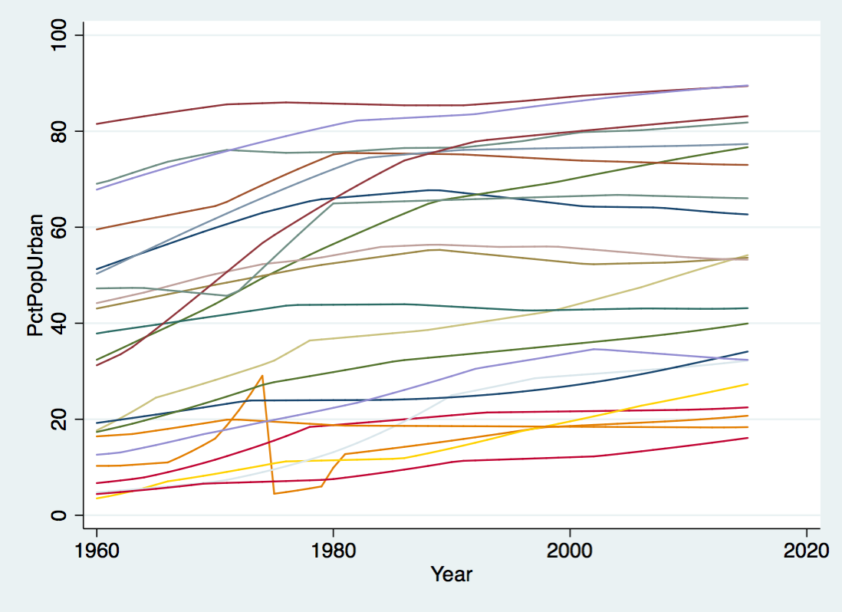

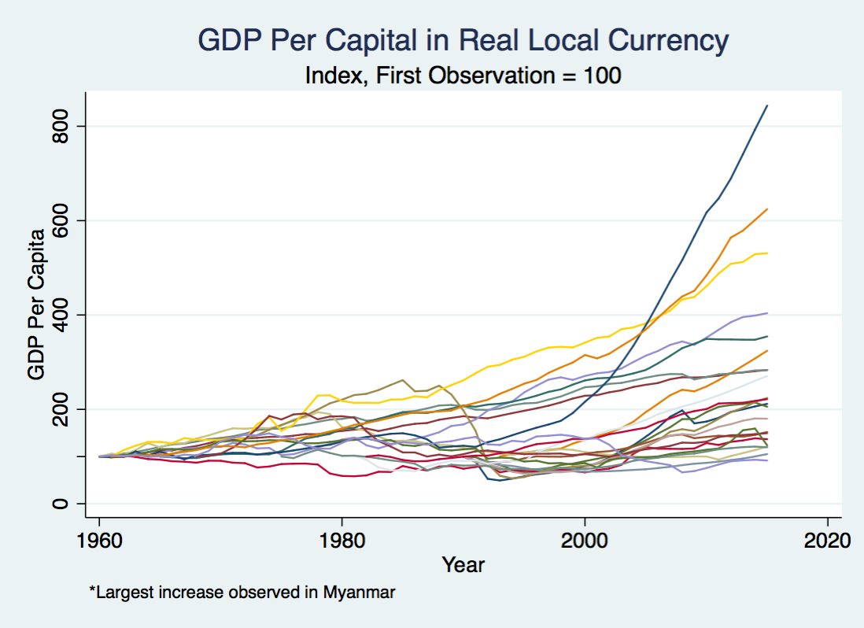

## Panel 2 (GDPPerCapRealLCU_2)

Panel members include: Armenia; Australia; Czech Republic; Djibouti; Egypt, Arab Rep.; Georgia; Kazakhstan; Cambodia; Sri Lanka; Myanmar; Mozambique; Saudi Arabia; Suriname; Chad; Uganda

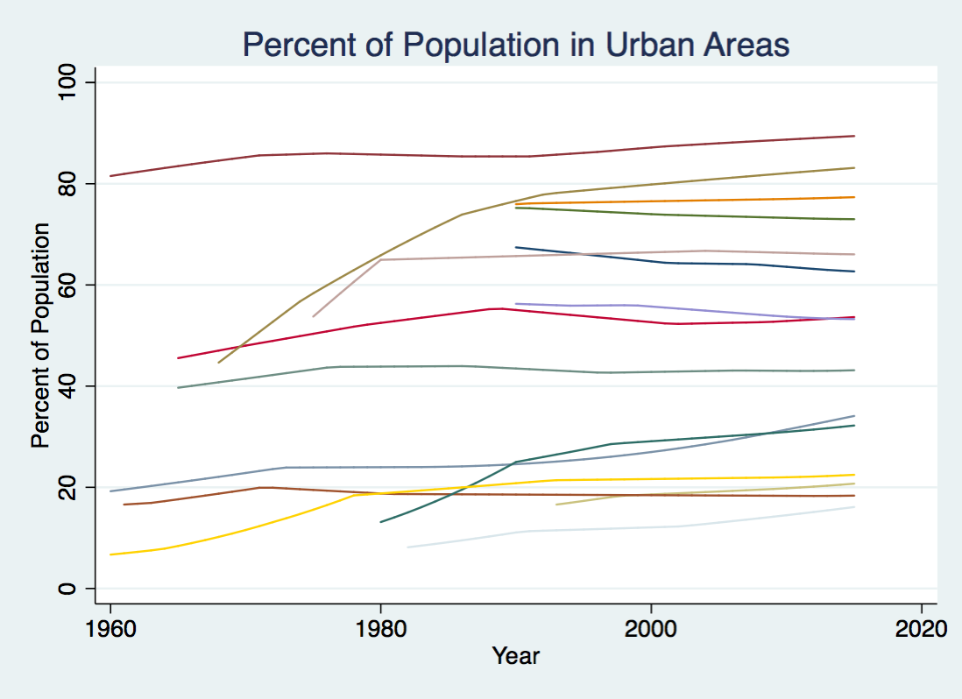

* Data shown only for years where GDPPerCapRealLCU is recorded

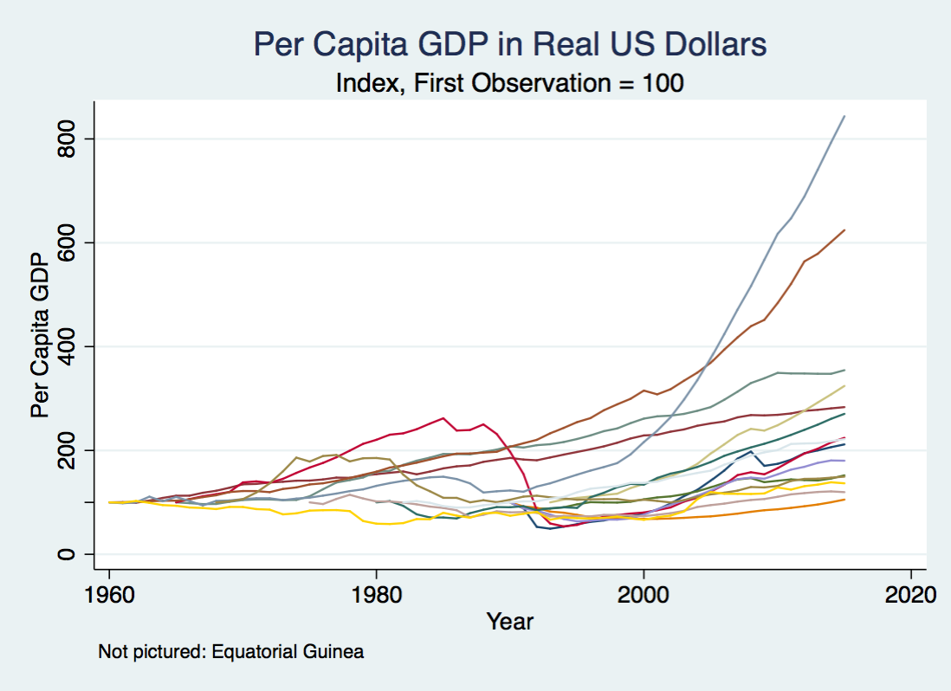

## Panel 3 (GDPPerCapRealUSD)

Panel members include: Albania, Armenia, Bulgaria, Cameroon, Cuba, Czech Republic, Djibouti, Algeria, Ethiopia, Equatorial Guinea, Kazakhstan, Kyrgyz Republic, Cambodia, Mozambique, New Zealand, Sudan, Tanzania, Uzbekistan, South Africa

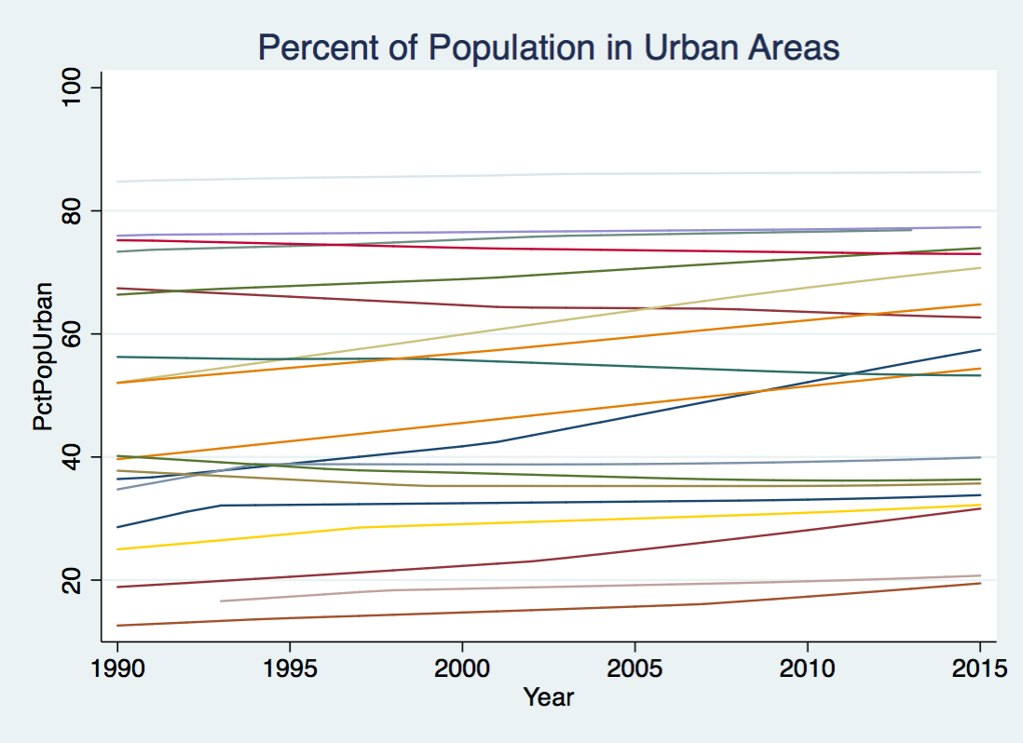

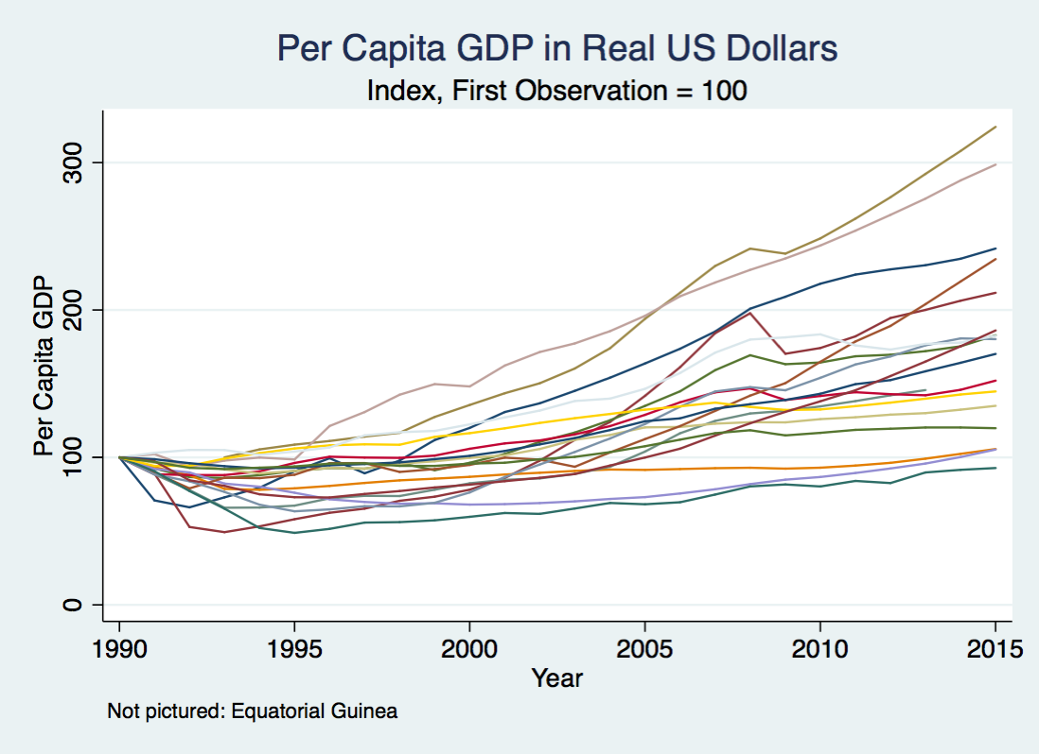

## Panel 4 (GDPRealLCU)

Panel members include: Armenia; Australia; Belarus; Belize; Czech Republic; Djibouti; Egypt, Arab Rep.; Georgia; Kazakhstan; Cambodia; Myanmar; Suriname; Uganda

